User Manual

House Hold Management System

*For*

E-Shift

**Project details**

Title : User Manual of House Hold Management System for E-Shift

Student Name : Sulakkhana Indeepa Dissanayake

Registration No : 00125085

# **Introduction**

**This is Document provides all the guides in order to operate this system. Please follow the given guide lines before use this system**.

## Fuctionalities of Administrator

Below are the basic functionalities that the system is capable of performing.

* User Level & Access Management:
* Only the administrator has the privilege to manage the customer and grant and revoke the access permission.
* Customer Management
* Manage all functionalities of Customers.
* Adding new Customers to the system and provide access to the system.
* Employee Management
* Employees can only be managed by the administrator.
* Manage employees and allocate them to units.
* Unit Management
* Admin can add new units.
* Administrator can assign employees and a lorry to a unit
* Admin can edit the unit details
* View unit details
* Lorry management
* Add, update lorries to the system
* View the Lorry Info
* Job management
* Exam date is updated here when the government change the dates
* Manage and maintain the exam and trial information
* View results
* Product Management
* Upload video sessions that has been conducted before and past papers to the system. Students who missed the lectures can watch them

## Functionalities of Customer

* User Registration
* Once Customer/Employee registered in the system, they will get the permission to access their profile after admin gives the access.
* Secure Login
* Customer can login to the system by providing their username and password.

* Request For Jobs
* Customer can request for jobs
* Customer can view requested jobs
* Customer can update product Info and cancel a requested job
* Manage Customer Profile
* Customer should be able to login and manage their own profile.

.

# **Guide Lines**

## Guide lines for admin functionalities

# 

First you need to provide your username and password in order to login. Since you have the admin privilege you will be redirected to the **Admin Dashboard Page** which is being explained in next step**.** If you type something wrong you can click on clear. But when a customer login to the system he will be redirecting to the Customer Dashboard Page. For a new customer he/she has to be registered with the system by going to customer registration page. In order to do so customer needs to click on the button ‘Register’ on the top and go to **Customer Register Page.**

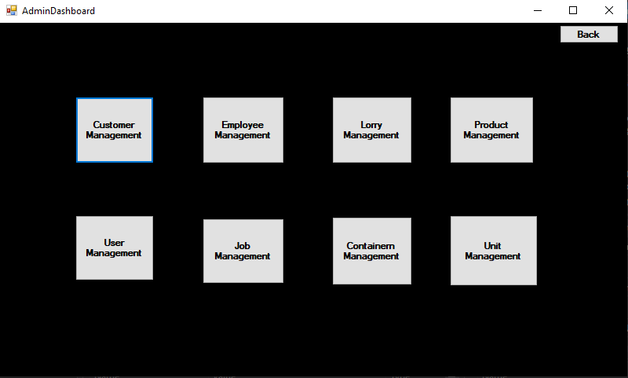

Admin Dashboard contains the entry points in order to access major management areas of this system. Once user click on a particular area user will be navigated to the relevant form of that management area.

## Customer Management

According to following image, all the customers will be shown in the table whereas the form getting loaded. Once you click on a particular row, the relevant customer would be copied to the text boxes and so the admin can update or delete the customer. Update and delete buttons will not be enabled until the user click on a row in the table.

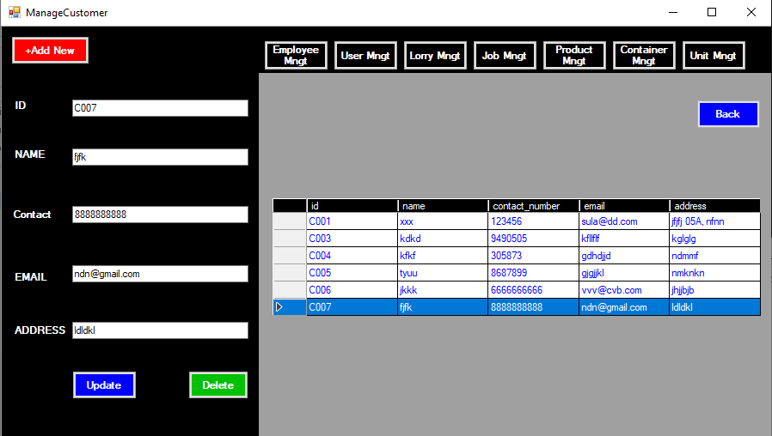

## Employee Management

According to following image, all the employees will be shown in the table whereas the form getting loaded. Once you click on a particular row, the selected employee would be copied to the text boxes and so the admin can update or delete the employee and can be assigned a job position as well. Update and delete buttons will not be enabled until the user click on a row in the table.

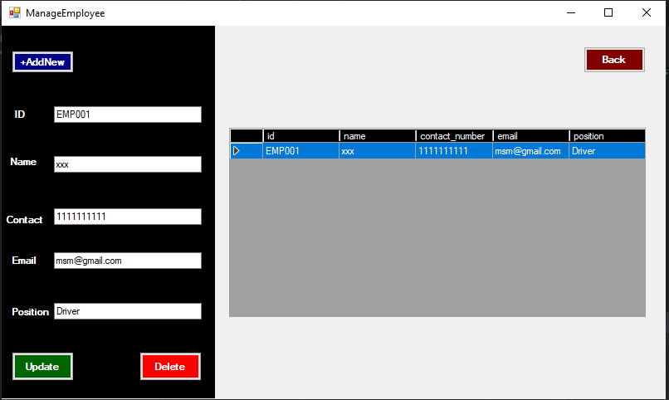

## Lorry Management

According to following image, all the Lorries belongs to the company will be shown in the table whereas the form getting loaded. Once you click on a particular row, the selected lorry would be copied to the text boxes and so the admin can update the current status of the lorry or delete it and can. Update and delete buttons will not be enabled until the user click on a row in the table. Once you click on the ‘+Add New’ system will automatically generate a new id to the lorry whereas button ‘update’ change its name to ‘save’. So then you can save the new lorry to the database.

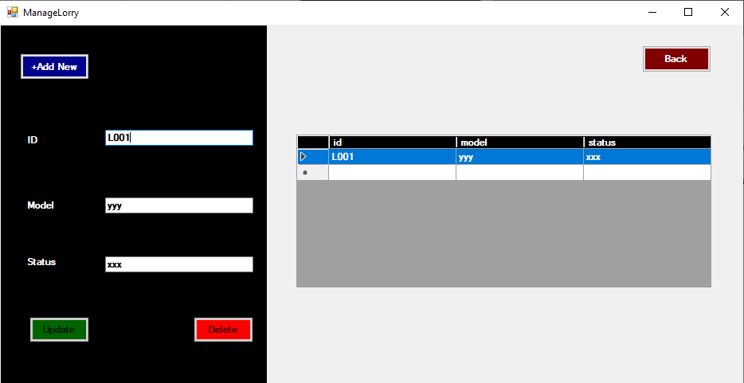

## Product Management

According to following image, all the products belongs to a particular job id will be shown in the table whereas the form getting loaded based on the given job id in the job id text box. Once you click on a particular row, the selected product would be copied to the text boxes and so the admin can update the current quantity of the product or delete it. Update and delete buttons will not be enabled until the user click on a row in the table. In order to add a new product +Add New has to be clicked and then then the system will automatically generate a new ID for the new entity and button Update will change its text value to ‘Save’. So once the ‘Save’ button is clicked new information regarding the product will be saved in the database.

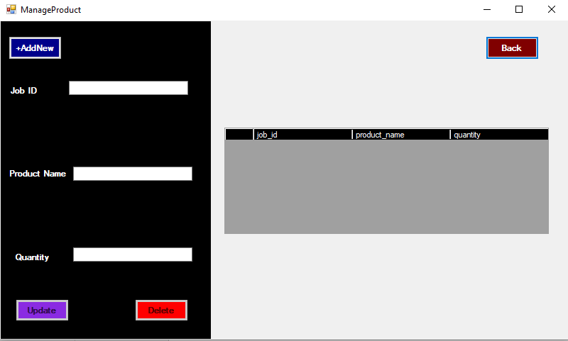

## User Management

According to following image, all the User Management functionalities are going under this form. You can add users under two roles that is ‘admin’ and ‘customer’. Customers deserves the customer privilege. Selected employees are added with the admin privilege. So you can select a customer or employee id from the drop down box and add to the database. Thereafter they will be able to access the system based on their role. Users who are having the admin privilege will be redirecting to the admin dashboard after login and customers to the customer dashboard. Like in previous modules you cannot create new users here. Instead of that this form only allows you to add registered customers and employees as the system users.

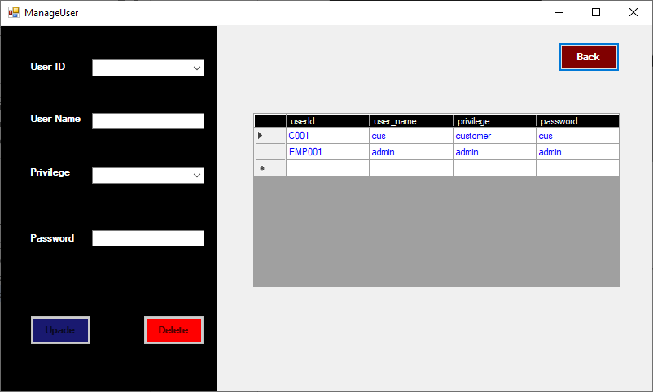

## Job Management

According to following image, all the Job are managing under this form. You can add new jobs and assign a available unit to the job as per the customer request. In order to add a new job first click on the ‘Add New’ and system generates a new job id. Once you click on it button ‘update turn its name to ‘save’. Select the job date that the job should be completed through the date picker and also mention the unit id that should be assigned. After clicking on the ‘save’ new data will be saved in the database. By selecting a row in the table, selected job details will be copied to the form elements and so you can edit or delete that particular job.

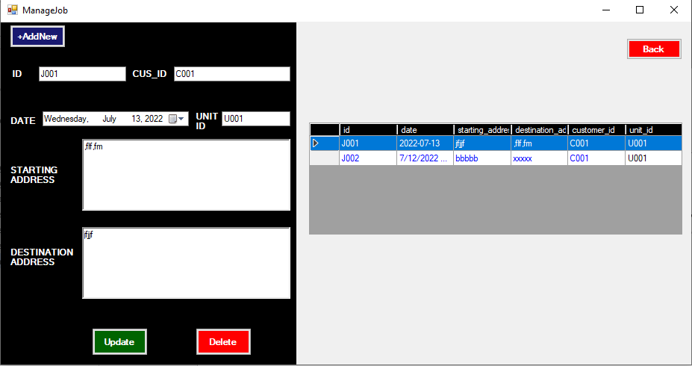

## Container Management

According to following image, all the Containers belongs to the company will be shown in the table whereas the form getting loaded. Once you click on a particular row, the selected container details would be copied to the form elements and so the admin can update the container details or delete it. Update and delete buttons will not be enabled until the user click on a row in the table. Once you click on the ‘+Add New’ system will automatically generate a new id to the container whereas button ‘update’ change its name to ‘save’. So then you can save the new container to the database.

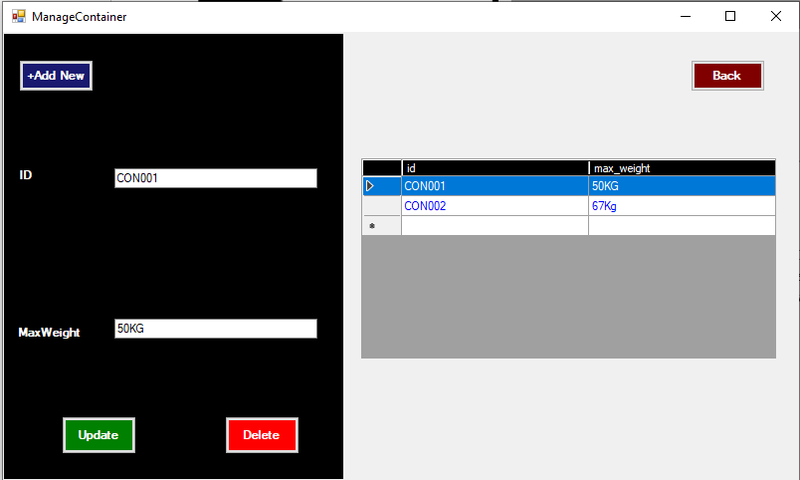

## Unit Management

According to following image, all the Units that already created will be shown in the table whereas the form getting loaded. Once you click on a particular row, the selected unit details would be copied to the form elements and so the admin can update the unit details or delete it. Update and delete buttons will not be enabled until the user click on a row in the table. Once you click on the ‘+Add New’ system will automatically generate a new id to the unit whereas button ‘update’ change its name to ‘save’. So then you can save the new container to the database. This is the place where you can assign a driver and an assistant and a container to a particular unit.

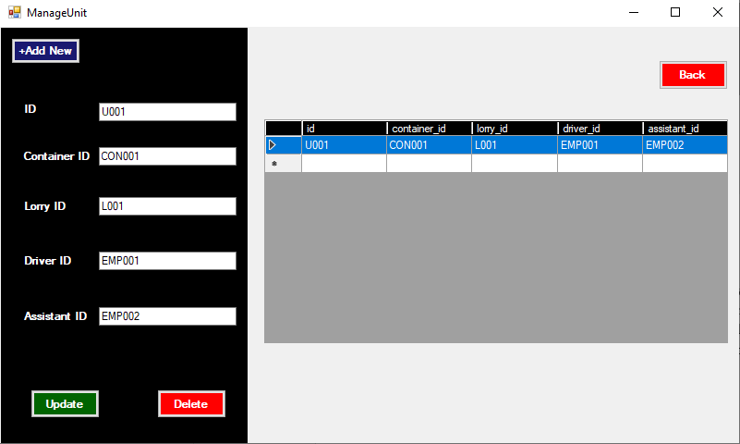

## Guide lines for Customer functionalities

## Customer Registration

As mentioned in the login page, new customers must be registered with the system. So customer needs to go to registration page by clicking on the register button in the login page, Fill the required details and click on the register button in the registration page. Once the admin approved the customer as a user. Then customer will be able to login as customer

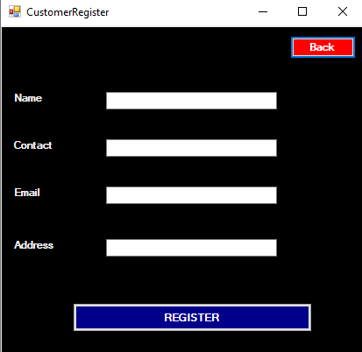

## Customer Dashboard

Customer Dashboard contains the entry points in order to access customer profile module and request for a job module. Once logged customer click on a particular module, he/she will be navigated to the relevant form. The image given below provide a more clear idea.

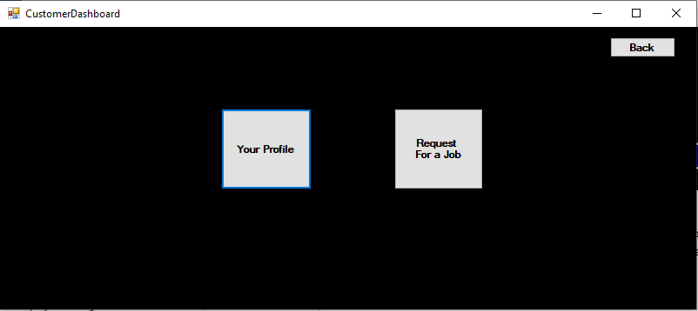

## User Profile

The image given below show the user profile form and is used to display and update registered customer information. This can only be accessed by the customer who is the owner of the relevant profile. So he/she can display their own details and update the details just clicking on the update button.

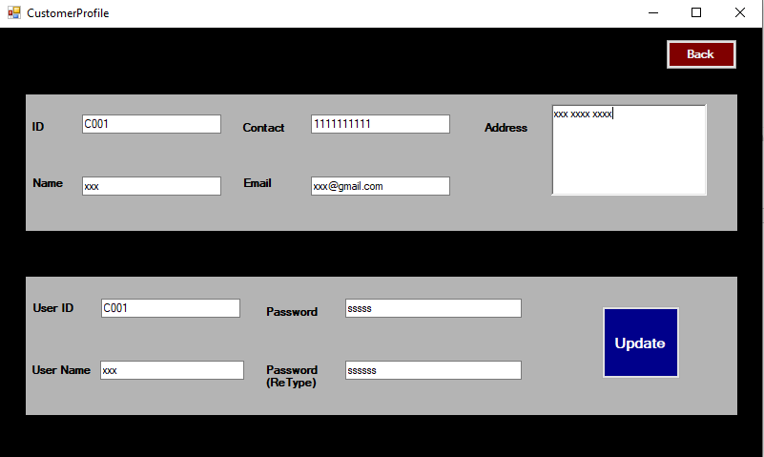

## Request For a Job

According to following image, all the Job request from the customers side should be done here.The requests that has already been created by the particular customer will be shown in the table whereas the form getting loaded. Once you click on a particular row, the selected job details would be copied to the form elements and so the customer can update the product info or cancel it. Update and delete buttons will not be enabled until the user click on a row in the table. Once you click on the ‘+Add New’ system will automatically generate a new id for a new job whereas button ‘update’ change its name to ‘save’. So then you can save the new job to the database. Once the admin approve the job, the status will be updated to ‘approved’.

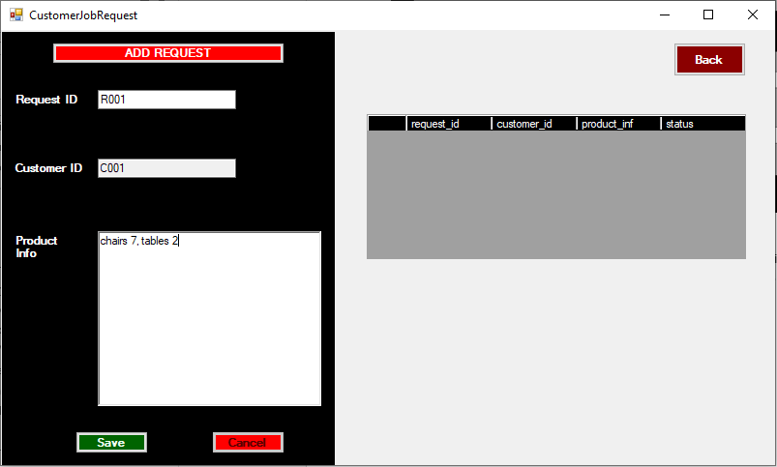

# Resource Requirements

Below tables shows the main resource requirements in order to run the system.

**Development Environment**

|  |  |
| --- | --- |
| **HARDWARE ENVIRONMENT** | **SOFTWARE ENVIRONMENT** |
| Intel (R) Pentium (TM)4@CPU 3.0GHz | MS Window 10 |
| 8GB RAM | C# 4.5 |
| 160GB HDD | MYSQL Server |
| Printer | Git and Git Hub |
| Router and Internet Connection |  |
|  |  |
|  |  |
|  |  |

Table 1 – Required Resources

# 

# 